**WEEK 8 HANDS_ON EXERCISES**

**EXERCISE 1:**

git config --global user.name "S. Pranith Kumar"

git config --global user.email "pranith@gmail.com"

git config --global –list

notepad++

git config --global core.editor "notepad++ -multiInst -notabbar -nosession -noPlugin"

git config --global -e

mkdir GitDemo

cd GitDemo

git init

echo "Welcome to Git Lab exercise" > welcome.txt

git status

git add welcome.txt

git commit

git status

git remote add origin https://github.com/yourusername/GitDemo.git

git push -u origin main

**OUTPUT:**

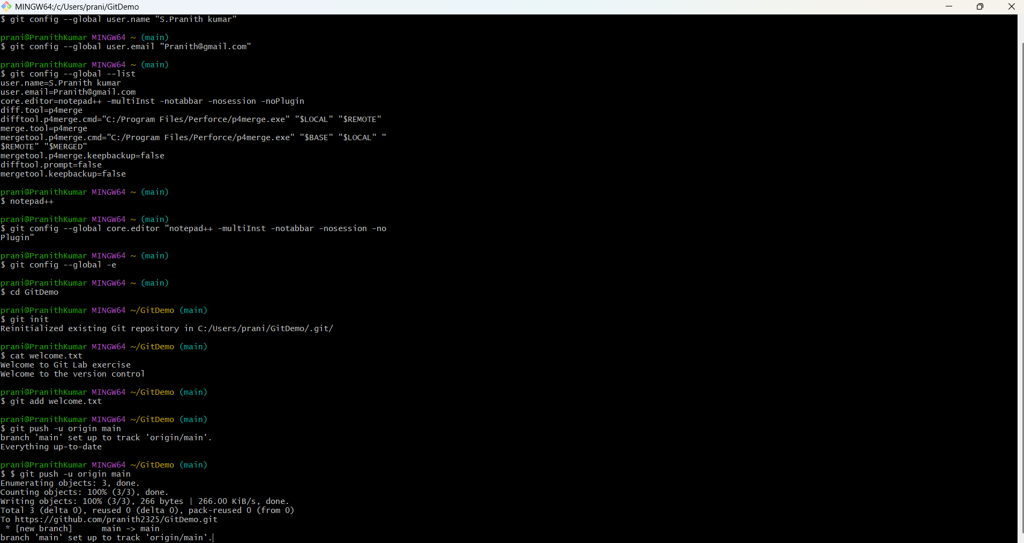

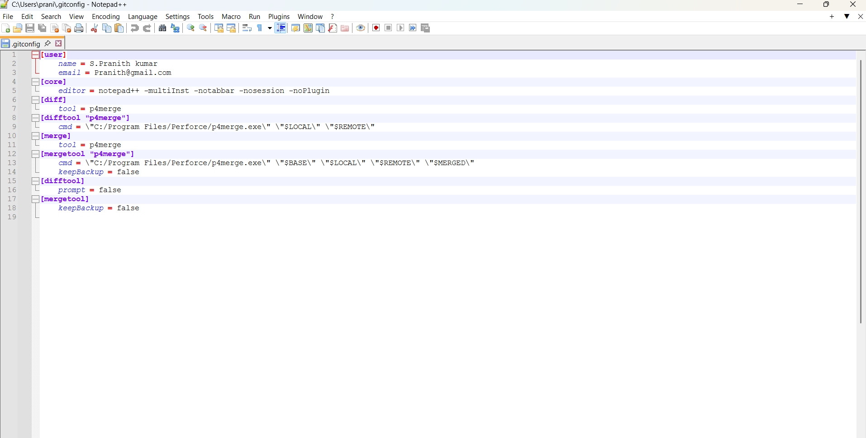

**EXERCISE 2:**

git init

echo "This is a log file" > error.log

mkdir log

echo "Log content" > log/app.log

notepad++ .gitignore

git status

cd GitDemo

git add .

git commit -m "Ignore log folder using .gitignore"

git rm -r --cached GitDemo/

git add .

git commit -m "Ignored nested GitDemo folder"

git status

git push

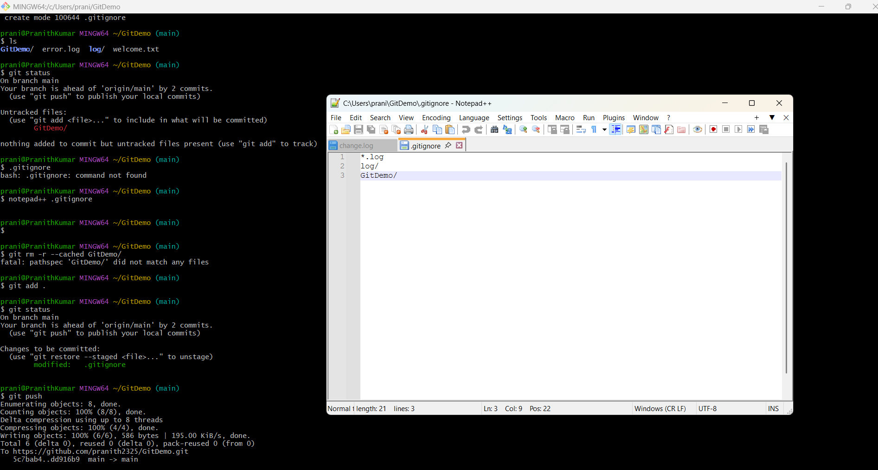

**EXERCISE 3:**

git branch GitNewBranch

git branch -a

git switch GitNewBranch

echo "This is a new file in GitNewBranch" > newfile.txt

git add newfile.txt

git commit -m "Added newfile.txt in GitNewBranch"

git status

git switch main

git config --global diff.tool p4merge

git diff GitNewBranch

git log --oneline --graph –decorate

git branch -d GitNewBranch

git status

**OUTPUT:**

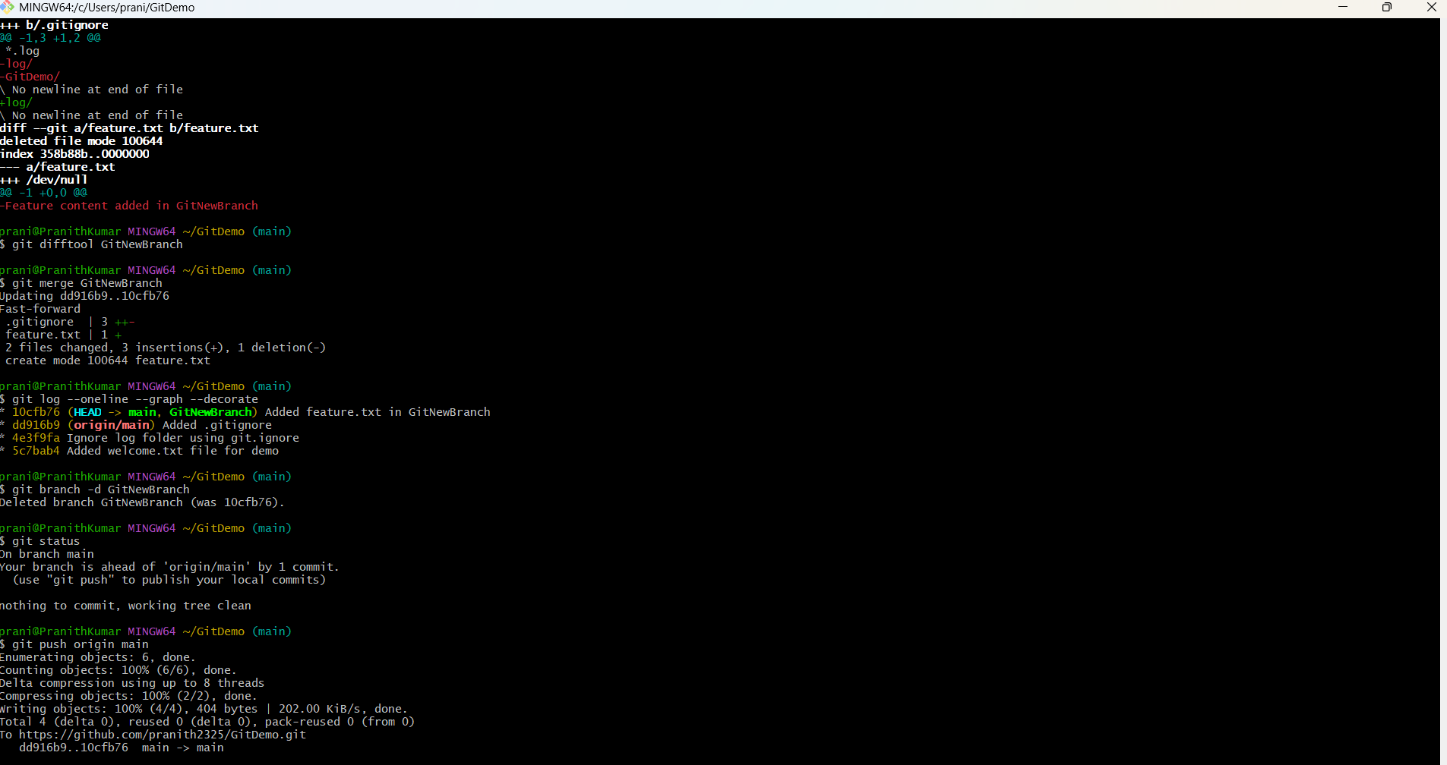

**EXERCISE 4:**

git checkout main

git status

git checkout -b GitWork

echo "<message>Hello from GitWork</message>" > hello.xml

echo "<new>Change from GitWork branch</new>" >> hello.xml

git status

git add hello.xml

git commit -m "Updated hello.xml in GitWork branch"

echo "<message>Hello from master</message>" > hello.xml

git diff GitWork

git difftool -t p4merge GitWork

git merge GitWork

git mergetool

git add hello.xml

git status

echo "*.orig" >> .gitignore

git branch

git branch -d GitWork

git log --oneline --graph –decorate

git status

git push origin main

**OUTPUT:**

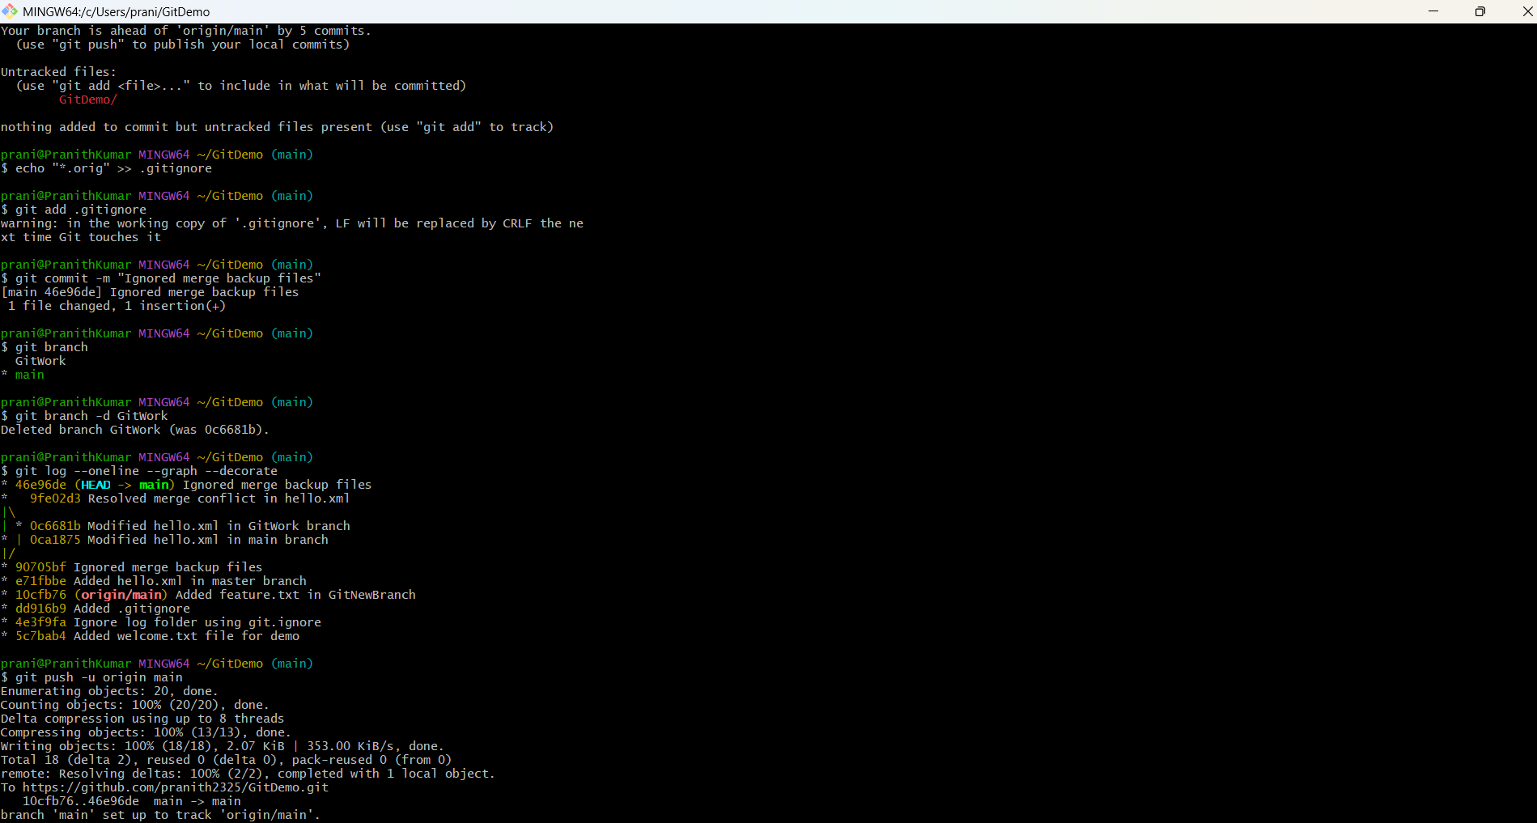

**EXERCISE 5:**

git status

ls

git branch

git branch -a

git pull origin main

git push origin main

**OUTPUT:**

